**OPERATING**

**SYSTEM**

**LAB – 6**

**Shell Script**

**Submitted by: ~**

**Ayushi Kumari**

**RA1911003010865.**

1. **Given the following values**

**num=10, x=*, y=`date` a="Hello, 'he said'"**

**Execute and write the output of the following commands.**

|  |  |
| --- | --- |
| **Command** | **Output** |
| echo num | num |
| echo $num | 10 |
| echo $x | Desktop Documents Downloads Extra.sh Music Pictures Public Ques1.sh Ques2.sh Ques3.sh Ques4.sh Templates Videos |
| echo ‘$x’ | ‘*’ |
| echo “$x” | “*” |
| echo $y | Thu Mar 25 09:59:07 PDT 2021 |
| echo $(date) | Thu Mar 25 09:59:07 PDT 2021 |
| echo $a | Hello,'he said' |
| echo \$num | $num |
| echo \$$num | $10 |

1. **Find the output of the following shell scripts.**

$ vi ex51

echo Enter value for n

read n

sum=0

i=1

while [ $i –le $n ]

do

sum=$((sum+i))

i=$((i+2))

done

echo Sum is $sum

**OUTPUT: -**

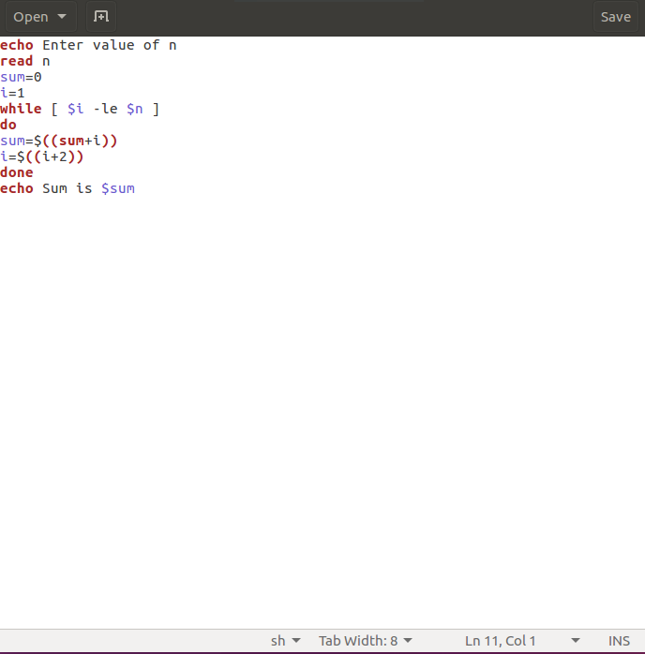

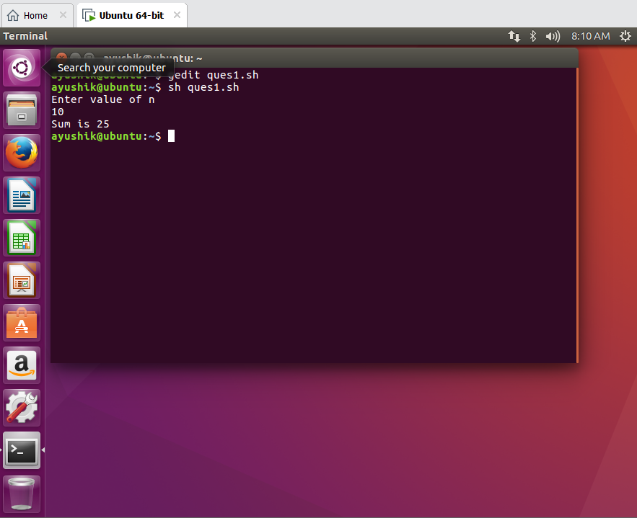

1. **Q2. Write a program to check whether the file has executed permission or not. If not, add the permission.**

**$ vi ex52.**

echo Enter name of the file

read name

if [ -x $name ]

then

echo Yes $name has Execute Permission

else

echo No $name has No Execute Permission

fi

**OUTPUT: -**

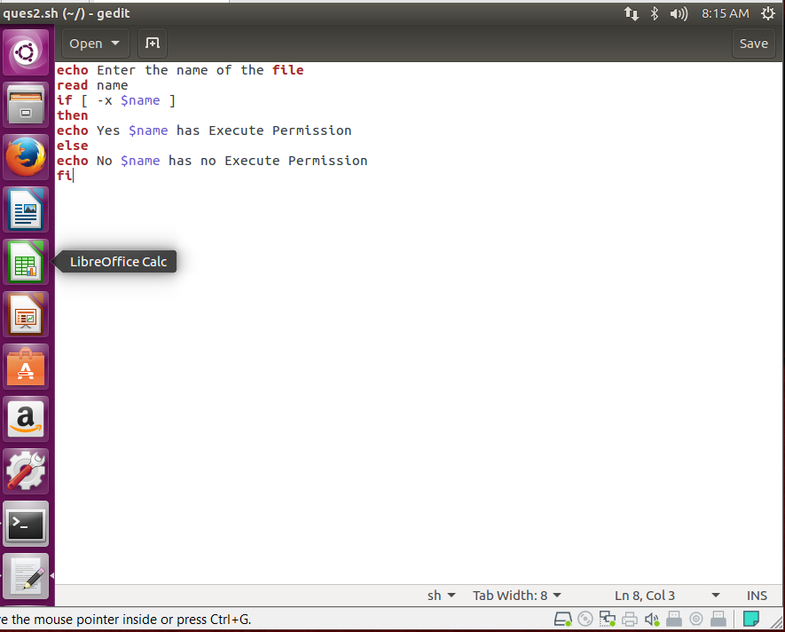

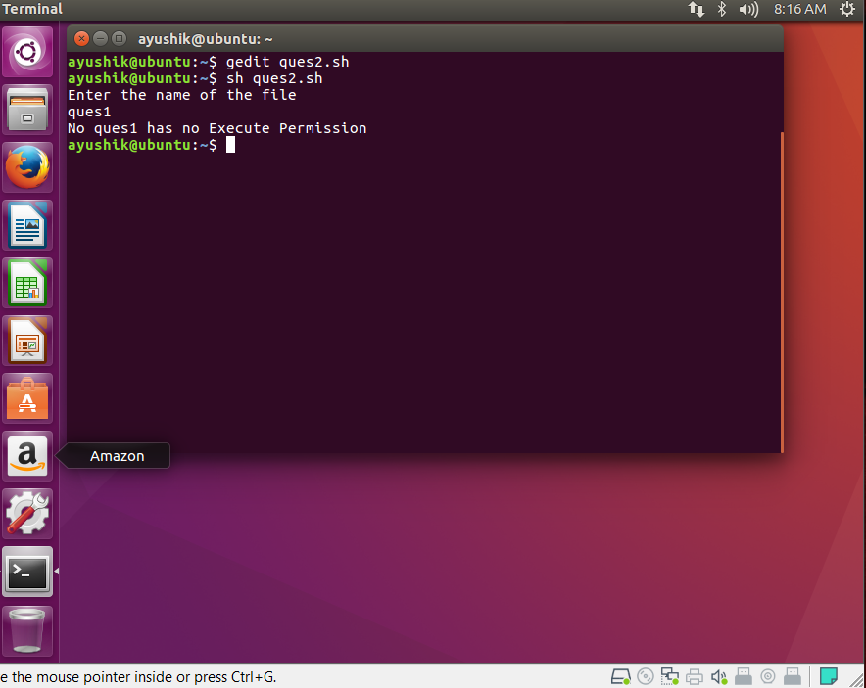

1. **Q3. Write a shell script to print a greeting as specified below.**

**If hour is greater than or equal to 0 (midnight) and less than or equal to 11 (up to 11:59:59),"Good morning" is displayed.**

**If hour is greater than or equal to 12 (noon) and less than or equal to 17 (up to 5:59:59p.m.), "Good afternoon" is displayed.**

**If neither of the preceding two conditions is satisfied, "Good evening" is displayed.**

**$ vi ex53**

**hour=$(date | cut -c12-13)**

**if [ "$hour" -ge 0 -a "$hour" -le 11 ]**

**then**

hour=$(date | cut -c12-13)

if [ "$hour" -ge 0 -a "$hour" -le 11 ]

then

echo Good Morning

elif [ "$hour" -le 17 ]

then

echo Good Afternoon

else

echo Good Evening

fi

**OUTPUT: -**

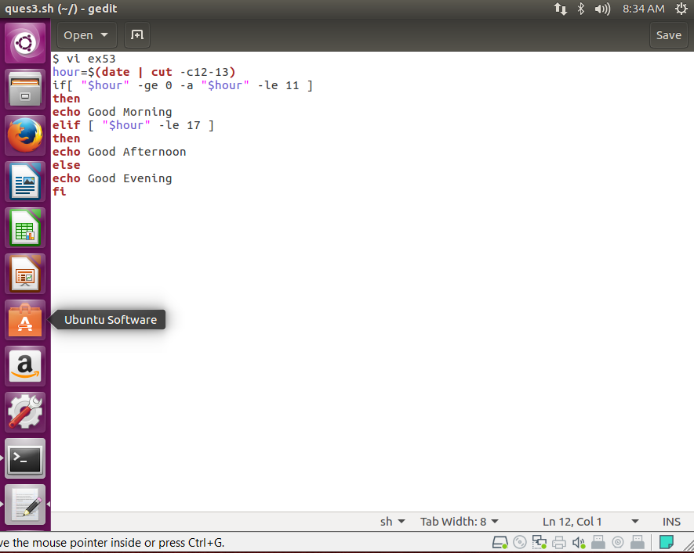

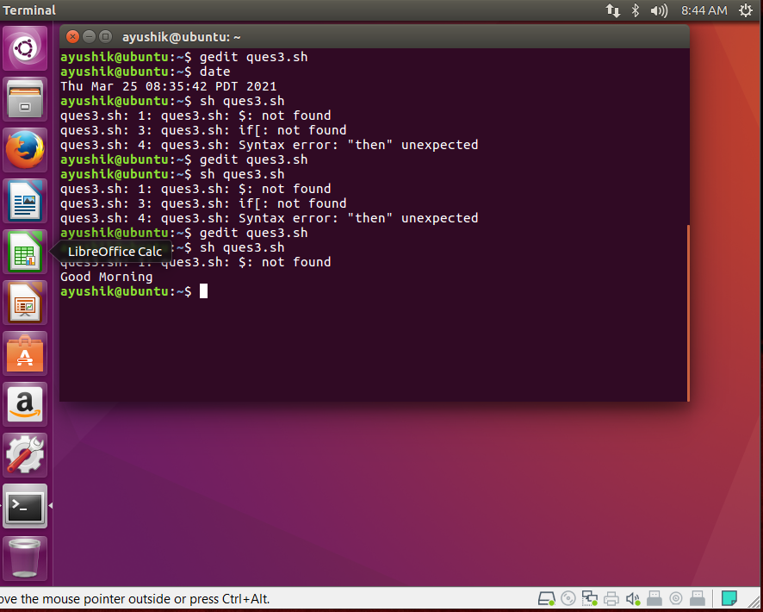

1. **Write a shell script to list only the name of sub directories in the present working directory.**

**$ vi ex54.**

for i in *

do

if [ -d $i ]

then

echo $i

fi

done

**OUTPUT: -**

